 | CASE STUDY 16:  An organization registers a contact person.

Objective:
To register a core reference record containing contact information through the Management Centre.

References:
BCH Training site: http://bchtraining.cbd.int
BCH Module 6: Using the Management Centre

Scenario:

As the information officer for a biosafety organization, you are likely to be using the BCH to register several records where you will be the contact person for further information. In order to avoid having to type this information in several times, you want to create a record containing your contact details for later reference. Your business card is attached below.
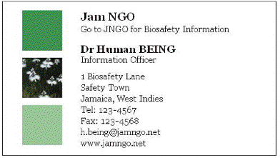

 | CASE STUDY 16:  An organization registers a contact person.

TRAINER NOTES

Training Objective:
Experience the process of using the Management Centre to create a new core reference record.

Requirements:
A BCH account, registered as a general user, capacity-building organization or government, and access to the BCH.

Notes:
- Users can work singly or in small groups for this exercise.
- Participants should log-on using their own account through the training site.
- Participants are requested to enter their personal contact information – Instructors may wish to advise them that if they feel any discomfort providing this information, they may instead register fictitious information.
- Records should be kept in the Management Centre for use in later exercises.
- If you are unable to access the BCH, users could fill out the details on a hard copy of the common format.

The international dialing code for Jamaica is +1-876.

